Comparative Study of Neostigmine and Ketamine as Additives to Plain Bupivacaine in Caudal Analgesia after Lower Abdominal Surgery in Pediatrics
Omar Mohey Eldin A. El-Maksoud MD, Ehab El -Shahat Afifi MD, Ahmed Mostafa A. El-Hamid MD and Ahmed A. Mosaad M.Sc.
Abstract:
Purpose: This study was designed to compare the effects of Neostigmine vs. Ketamine co-administered caudally as adjunct to local anesthesia in children.
Patients and methods:
The study comprised 75 children aged between 2 and 14 years undergoing elective lower abdominal surgeries.
Patients were divided randomly into three equal groups: Group I (control group): Plain Bupivacaine 0.25% (0.5ml/kg). Group II: Plain Bupivacaine 0.25% (0.5ml/kg) mixed with Neostigmine 2µg/kg. Group III: Plain Bupivacaine 0.25% (0.5ml/kg) mixed with Ketamine 0.5mg/kg. At the end of the surgery and before recovery from the general anesthesia, caudal analgesia was performed. All patients were observed at 30min., 4h, 6h, 8h, 12h, and 24h postoperative to evaluate: Level of analgesia, Stress hormones (cortisol and Bl.glucose) level, Hemodynamic parameter and Post anesthetic side effects.
Results: Addition of either Neostigmine or ketamine to caudal bupivacaine significantly prolonged its analgesic effect but the bupivacaine-neostigmine mixture had longer effect than bupivacaine or bupivacaine-ketamine mixture. In patients receiving neostigmine added to caudal bupivacaine, we noticed hemodynamic stability, pain scores showing no or minimal pain, normal hormonal levels and no major complications were noticed. This analgesic effect of both drugs extends from 16 to 20 hours postoperatively.
By this study, epidural neostigmine has proved to be safe in the concentration used and proved to prolong the local anesthetic analgesic duration by a period that reached up to 20 hours postoperatively.
Conclusion: The current study establishes Bupivacaine neostigmine and Bupivacaine ketamine caudal mixtures produced longer duration of postoperative analgesia after lower abdominal surgery in pediatrics than caudal bupivacaine alone.
Introduction:
Caudal analgesia is the most popular and commonly used regional anesthesia technique for post-operative analgesia in children undergoing lower, anoperineal and abdominal surgical procedures. It is commonly applied in all the pediatric patients undergoing the above mentioned surgery, as the goal of balanced anesthesia is not only limited to intraoperative period but also good analgesia in post-operative period⁽¹⁾ .The quality and level of the caudal blockade is dependent on the dose, volume, and concentration of the injected drug. Although it is a versatile block, one of the major limitations of the single-injection technique is the relatively short duration of postoperative analgesia. The most frequently used method to further prolong postoperative analgesia following caudal block is to add different adjunct drugs to the local anesthetics solution⁽²⁾.Adding neostigmine to Bupivacaine offers an advantage over Bupivacaine alone for post-operative pain relief in children undergoing lower abdominal surgeries with minimal incidence of adverse effects⁽³⁾.Extradural Ketamine produces analgesia by a spinal mechanism. This (NMDA) receptor antagonist is devoid of opioids side effects but may produce behavioural side effects. In children, addition of Ketamine to local anaesthetics prolongs the duration of postoperative analgesia after inguinal hernia repair and orchidopexy ⁽⁴⁾.
Patients and methods: After approval of the local ethical committee and parent’s consent, this prospective single blinded clinical study was conducted on 75 children aged between 2 and 14 years old, ASA grade I and ІІ of both sexes. All children were scheduled for elective lower abdominal Surgeries. (Table 1)
Type of surgery | Group I | Group II | Group III
Congenital Inguinal Hernia | 11 | 11 | 10
Hypospadias | 5 | 4 | 3
hydrocele | 4 | 5 | 6
Undescended Testis | 5 | 5 | 6
Total | 25 | 25 | 25

Exclusion criteria included children with bleeding diathesis, neuromuscular or spinal diseases, children with back problems and local skin infections of the caudal area, children with mental retardation or delayed development and known allergy to the trial drugs. Patients were randomly allocated by closed envelope into three equal groups according to the type of caudally injected drug:
Group I: received plain Bupivacaine 0.25% (0.5ml/kg)
Group II: received plain Bupivacaine 0.25% (0.5ml/kg) mixed with Neostigmine 2µg/kg.
Group III: received plain Bupivacaine 0.25% (0.5ml/kg) mixed with Ketamine 0.5mg/kg.
At the end of surgery and before recovery from the general anesthesia, patients were put in the left lateral position, with flexed hips and knees. After complete sterilization, caudal analgesia was performed using 22-gauge needle guided by 2 sacral cornu and tip of coccyx, after negative aspiration to ensure no blood or CSF, the drug was injected according to each group.
The primary outcome was the Quality of analgesia which was assessed using a modified objective pain discomfort scale (OPDS) at the same intervals as the secondary outcomes.
The secondary outcomes include the following parameters recorded at 30min., 4h, 6h, 8h, 12h, and 24h postoperative:
- Heart rate.
- O₂ saturation.
- Mean arterial blood pressure.
- Respiratory rate.
- Measurement of stress hormones level (cortisone & Bl. Glucose)
- Time at the 1st analgesic request. (i.e. at which analgesia in the form of paracetamol suppository will need.
- Post anesthetic side effects, if any, were reported as:
- Delayed motor weakness (inability of the patient to stand unaided after 6 hours from caudal injection).
- Respiratory depression (Respiratory rate < 12/min).
- Pruritus, urine retention or vomiting.
Objective pain discomfort scale (OPDS) ⁽⁵⁾

Observation | Criteria | Points
Blood pressure | ± 10% Preoperative  > 20% Preoperative  > 30% Preoperative | 0  1  2
Crying | Not crying  Crying but responding to tender loving care (TLC)  Crying and does not respond to (TLC) | 0  1  2
Movement | None  Restlessness  Thrashing | 0  1  2
Agitation | Patient a sleep or calm  Mild  Hysterical | 0  1  2
Localization of pain | A sleep or states "No pain"  Cannot localize  Can localize | 0  1  2

Statistical analysis: Was done using SPSS version 16 and the tests used are Chi-squire and ANOVA tests. We based the sample size calculation according to the primary outcome. A value of p < 0.05 was considered statistically significant. And a P value < 0.001 was considered highly significant.
Results: Demographic characteristics show no statistically significant differences among the three groups as regards age, ASA, weight and sex.
Table (2): Demographic characteristics among the three groups
 |  | Group I |  | Group II |  | Group III |  | Test of significance | p
 |  | mean | SD | Mean | SD | mean | SD | Test of significance | p
Age |  | 6.2880 | 3.29195 | 5.7280 | 3.23258 | 5.9200 | 3.54941 | F = 0.2 | >0.05
Weight |  | 14.0400 | 1.24097 | 13.8120 | .95058 | 12.00 | 15.50 | F = 0.5 | >0.05
 |  | No. | % | No. | % | No. | %
Sex | M | 22 | 88 | 23 | 92 | 22 | 88 | X² = 0.28 | >0.05
Sex | F | 3 | 12 | 2 | 8 | 3 | 12 | X² = 0.28 | >0.05
ASA | I | 15 | 60 | 16 | 64 | 17 | 68 | X² = 0.34 | >0.05
ASA | II | 10 | 40 | 9 | 36 | 8 | 32 | X² = 0.34 | >0.05

As regards duration of postoperative analgesia group II had the longest duration of analgesia with a mean of 17.8400 hours, with a statistically highly significant difference (P<0.001) compared with group I and group III (Table 3 &Fig.1). Group I had the shortest duration of analgesia with a mean of 5.0280 hours with a statistically highly significant difference (P <0.001) compared with the other two groups. Group III follows Group II with a mean duration of analgesia 11.1920 hours with a statistically highly significant difference (P<0.001) compared with the other two groups.
Table (3): Comparison between three groups as regards duration of postoperative analgesia:
 | Mean | Std. Deviation | Minimum | Maximum | F | P
Group I | 5.0280 | 0.63214 | 4.00 | 6.00 | 747.6 | <0.001
Group II | 17.8400 | 1.39224 | 16.00 | 20.00 | 747.6 | <0.001
Group III | 11.1920 | 1.33445 | 9.00 | 13.00 | 747.6 | <0.001

*P value: significant
Figure(1):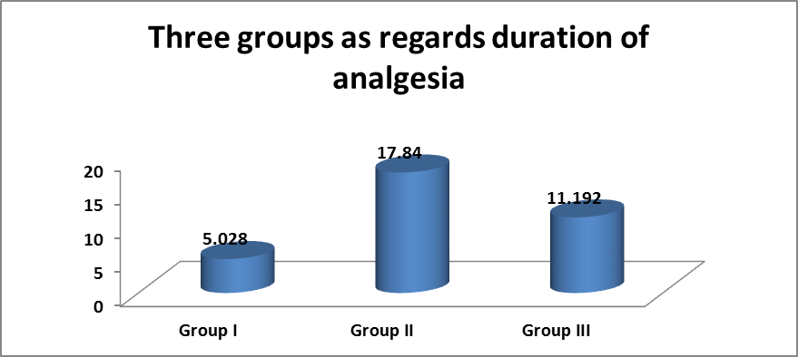

Pain score (Fig.2):
At 4 hours: The scores of the OPDS scale range from 1 to 4 in Group I and the scale was 0 in Group II. And the scale ranges from 0 to 1 in group III. So, there was statistically significant difference between groups’ ІI and ІІI with group І, and no statistical Difference between groups ІI and ІІI.
At 6 hours: The scores of the OPDS scale are from 3-6 in group І, 1- 2 in group ІІ and the scale was 2 in group ІІІ. So, there was statistically significant difference between both groups IІ and ІІI with group І. There are increased pain scores in group I, and no statistical difference between groups IІ and ІIІ.
At 8 hours: The scores of the OPDS scale are from 5-7in group І, and ranges from 2-3 in both group II and III. So, there was statistically significant difference between both group ІI and ІІІ with group І.
At 12 hours: The scores of the OPDS scale are from 6 - 8 in group І,3 in group II ,and ranges from 3-6 in group III.SO, there was statistically significant difference between group II with group I and III.
At 24 hours: The score of the OPDS scale ranges from 5-8 in the three groups with no significant difference in between.
Figure (2):
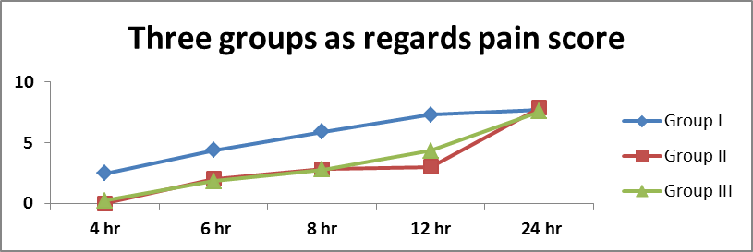
The mean values of Blood glucose level during the first 24 hours postoperatively showed no statistically significant difference (P > 0.05) among the three groups (Fig. 3).
Figure (3):
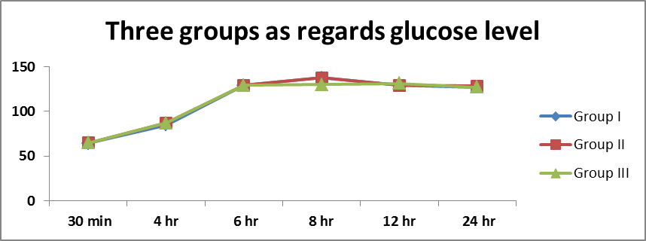
As regard cortisol level (Fig. 4)
At 30 min: There was no significant difference in between the three groups (p>0.05).
At 4 hours, at 6 hours, at 8 hours, at 12 hours: There was statistically significant difference between both groups ІI and ІІI with group І, and no statistical Difference between groups ІI and ІІI (p<0.001).
At 24 hours: Again there was no significant difference among the three groups (p>0.05).
Figure (4):
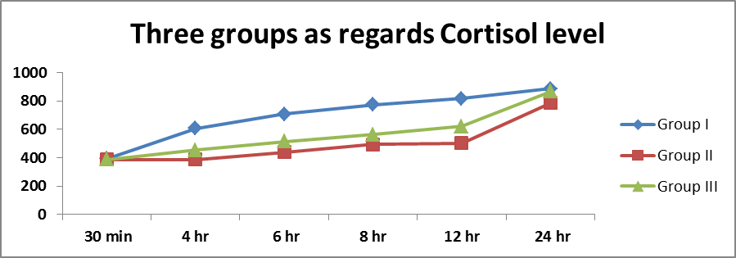
As regard Assessment of hemodynamic; Heart rate (HR), Mean arterial blood pressure Oxygen saturations and Respiratory rate,
The mean values during the first 24 hours postoperatively showed no statistically significant changes among the three groups (P >0.05) (Fig. 5, 6, 7, 8).
Figure (5):
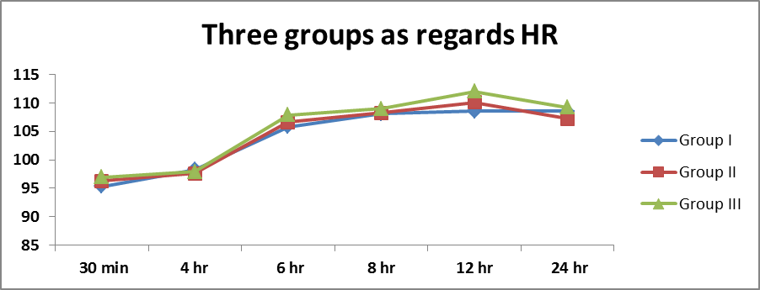
Figure (6):
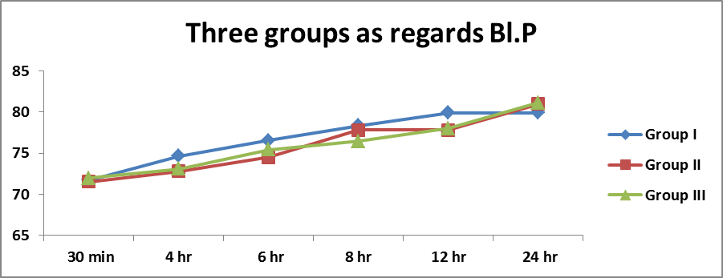

Figure (7):
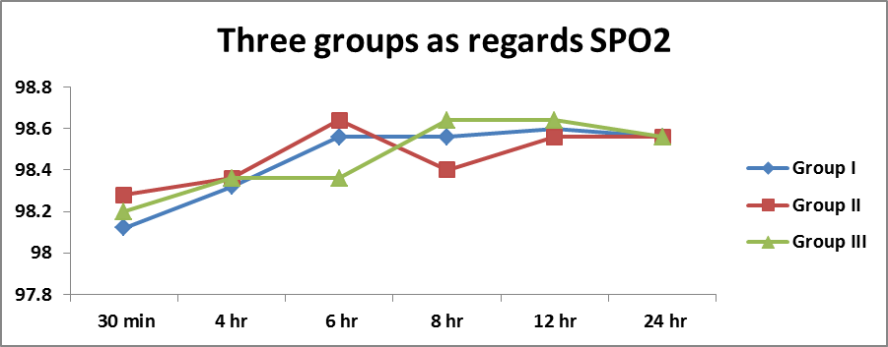
Figure (8):
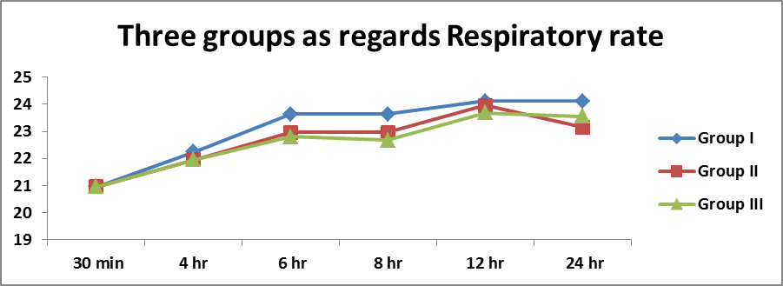
As regard Postoperative adverse effects: None of the children had Hypotension, bradycardia or respiratory depression. Two patients (8%) in bupivacaine group, four patients (16%) in bupivacaine neostigmine group and two patients in bupivacaine ketamine group (8%) suffered from vomiting. By the 4th postoperative hour, no residual motor block could be detected in any of the patients (Table 4).
(Table4):
 | Group I | Group II | Group III | X2 | p
Vomiting | 2 | 4 | 2 | 1.1 | >0.05
Hypotension | 0 | 0 | 0 | --- | ---
Bradycardia | 0 | 0 | 0 | --- | ---
Resp. depression | 0 | 0 | 0 | --- | ---

Discussion:
Caudal epidural analgesia is a widely employed technique for the management of pain within the distribution of T 10 - S 5 dermatomes, covering the lower abdomen, perineum and lower extremities ⁽¹⁾.In the present study As regards duration of postoperative analgesia group II (Bupivacaine neostigmine group) had the longest duration of analgesia, with a statistically highly significant difference compared with group I (Bupivacaine group) and group III (Bupivacaine Ketamine group).And this is in agreement with Rajesh Mahajan et al ⁽⁶⁾ who study 80 boys aged two to eight years scheduled for surgical repair of hypospadias were allocated randomly to one of four groups (n = 20 each) and received either only caudal 0.25% plain bupivacaine 0.5 mL/kg (Group I) or 0.25% plain bupivacaine 0.5 mL/kg with neostigmine (Groups II–IV) in doses of 2, 3 and 4 µg/kg respectively. The duration of postoperative analgesia in Group I was significantly shorter than in the other three groups. Total analgesic (paracetamol) consumption was significantly more in Group I than in the groups receiving caudal neostigmine. Also these results go with the study done by Lee and Sanders ⁽⁷⁾ on ropivacaine and ketamine Co administered caudally in children, and these results are also supported by Weber and Wulf ⁽⁸⁾ who showed a reduction of analgesic doses during the 1st 24 hours on adding ketamine to bupivacaine. And the present study agrees with Somasundaran and MadhuGarasia ⁽⁹⁾ who was Studied 100 pediatric patients undergoing infra-umbilical surgery. Cases were randomly allocated into three groups as follows: Group B: (n=34) who receives 0.75 ml/kg of 0.25% Bupivacaine caudally Group BK: (n=33) who receives a combination of Ketamine 0.5 mg/kg + 0.75 ml/kg of 0.25% Bupivacaine caudally ,Group BT: (n=33) who receives a combination of Tramadol 2 mg/kg + 0.75ml/kg of 0.25% Bupivacaine caudally , The mean duration of action after addition of Ketamine and Tramadol to Bupivacaine by the caudal epidural route was 9.3 h. and 7.9 h. respectively as compared to caudal Bupivacaine 4.0 h. Dinesh Kaushal et al ⁽¹⁰⁾ who studied 90 children were randomly allocated into three groups (n=30) to receive a caudal injection of either 0.25% bupivacaine 1ml/kg or with 2μg/kg or 5μg/kg neostigmine, he had found that Caudal administration of bupivacaine with the addition of neostigmine resulted in superior analgesia compared with the plain bupivacaine group. Recovery to first analgesic times was 6.05 ± 2.04 h., 11.5 ± 3.42 h. and 16.86 ± 4.92 h., respectively in the plain bupivacaine, bupivacaine with 2µg neostigmine and bupivacaine with 5µg neostigmine groups and this is in agree with the present study. As regard cortisol level and glucose level in the present study At 30 min; there was no significant difference in between the three groups. At 4 hours, at 6 hours, at 8 hours, at 12 hours, There was statistically significant difference between both groups ІI and ІІI with group І. And no statistical difference between groups ІI and ІІI .At 24 hours; Again there was no significant difference in between the three groups. DeBeer and Thomas ⁽¹¹⁾.As regards hemodynamic changes, our study revealed no significant changes in heart rate or mean arterial blood pressure among patients in the three groups whether those who received solitary drugs (bupivacaine) or those who received mixtures of drugs (bupivacaine with neostigmine and bupivacaine with ketamine). These results coincide with the studies done by Somasundrana and Madhu ⁽⁹⁾ and showed no significant hemodynamic changes all over the study period. As regard Postoperative adverse effects in our study none of the children had Hypotension, bradycardia or respiratory depression. Two patients (8%) in bupivacaine group, four patients (16%) in bupivacaine neostigmine group and two patients in bupivacaine ketamine group (8%) suffered from vomiting. By the 4th postoperative hour, no residual motor block could be detected in any of the patients. Abdulatif M and El Sanabary ⁽¹²⁾ they studied 60 boys, ASA physical status I, aged 2–10 yrs. undergoing hypospadias repair surgery. Patients were allocated randomly into one of three equal groups. Children in Group 1 received a caudal injection of 0.25% bupivacaine 1 mL/kg. Patients in Group 2 received an identical local anesthetic dosage mixed with neostigmine 2 µg/ kg. Group 3 received caudal neostigmine 2µ g/kg diluted in 0.9 NaCl solution to a total volume of 1 mL/kg.they found that vomiting occurred in the recovery room in 5 (25%), 2 (10%), and 6 (30%) patients in the caudal bupivacaine/neostigmine, bupivacaine, and neostigmine groups, respectively. Postoperative vomiting was not severe or repeated and was effectively managed with a single dose of IV Ondensetron 0.1 mg/kg. All children in the three study groups were able to stand unassisted at the sixth postoperative hours. No child had a recorded respiratory rate of < 15 breathes/min or showed any significant changes in heart rate and blood pressure in the first 24 postoperative hours. There were no Instances of postoperative sedation, hypotension, bradycardia, or pruritus. This goes with the results obtained by Olubukola et al 2007 ⁽¹³⁾ and Dinesh Kaushal et al 2009 ⁽¹⁰⁾, who found that vomiting occurred in the recovery room in 2 (6.7%), 5 (16.7%) and 10 (33.3%) patients in Group I, II, III respectively (p<0.05). Postoperative vomiting was not severe or repeated and was effectively managed with a single dose of I.V Ondensetron 0.1 mg/kg. Oral intake and discharge from hospital were not delayed. There were no instances of post-operative sedation, hypotension, bradycardia or pruritus, in any of the groups.
Conclusion: Bupivacaine neostigmine and Bupivacaine ketamine caudal mixtures produced longer duration of postoperative analgesia after lower abdominal surgery in pediatrics than caudal bupivacaine alone and were associated with some degree of motor block which was accepted as it had been of short duration. Bupivacaine neostigmine mixture had the longest duration of analgesia.
References:
- Pradhan B, Bajracharya GR (2008): Midazolam for caudal analgesia in children: Comparison with caudal bupivacaine. Katmandu Univ. Med J (KUMJ); 6(2): 166.
- Silvani P, Camporesi A, Agostino MR, Salvo I (2006): Caudal anesthesia in pediatrics: an update. Minerva Anestesial; 72(6):453.
- Tan F, Rowng DA, Doyle E(2000): Epidural and subarachnoid blockade in children. Anesthesia; 53:980.
- Panjabi N, Prakash S, Gupta P, Gogia AR (2004): Efficacy of three doses of ketamine with bupivacaine for caudal analgesia in pediatric inguinal herniotomy. Reg Anesth pain Med.; 29(1): 28.
- Hannallah RS, Broadman LM, Belman AB, et al (1987): Comparison of caudal and illioinguinal/illiohypogastric nerve blocks for control of post-orchiopexy pain in pediatric ambulatory surgery. Anesthesiology; 66:832-834.
- Rajesh Mahajan, MD, Vinod K. Grover, MD MNAMS and Pramila Chari, MD FAMS (2004): Caudal neostigmine with bupivacaine produces a dose-independent analgesic effect in children. Canadian Journal of Anesthesia 51:702-706.
- Lee HM, and Sanders GM (2000): Caudal ropivacaine and ketamine for postoperative analgesia in children. Anesthesia; 55: 798-810.
- Weber F, and Wulf H (2003): Caudal bupivacaine and s (+)-ketamine for postoperative analgesia in children. Pediatric Anaesth; 13:244-248.
- Somasundaran S,and Madhu Garasia(2008): A Comparative Study Of Ketamine And Tramadol As Additives To Plain Bupivacaine In Caudal Anaesthesia In Children. The Internet Journal of Anesthesiology.Volume 17 Number 2.
- Kaushal D, Singh V, Abbas H, Mallik A,and Singh G(2009) : Caudal bupivacaine-neostigmine for perioperative analgesia in pediatric patients undergoing infraumbilical surgeries: A prospective, randomized, double blind, controlled study. The Internet Journal of Anesthesiology. Volume 21 Number 1.
- Beer D,and Thomas ML (2003): Caudal additives in children - solutions or problems? Br J Anaesth; 90(4): 487-498.
- Abdulatif M, and El-Sanabary M (2002): Caudal neostigmine, bupivacaine, and their combination for postoperative pain management after hypospadias surgery in children. Anesth Analg; 95:1– 4.
- Olubukola O, Nafiu, FRCA, Richard A. Salam, and Eniol O(2007) : Comparison of Caudal Ketamine with or without Bupivacaine in Pediatric Subumbilical Surgery. JOURNAL OF THE NATIONAL MEDICAL ASSOCIATION. VOL. 99, NO. 6.

